


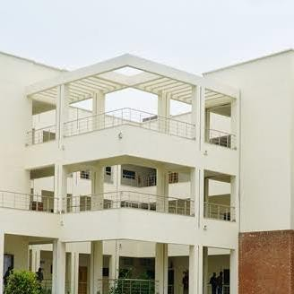
GROUP MEMBERS:
SUBMITTED TO: MS. MINA

DSA LAB

- Aneela Sarwar FA24-BCS-182
- M Okasha FA24-BCS-187
- Maheen Akhtar FA24-BCS-198
- Hassan Arshad FA24-BCS-199
Comsats University, Islamabad (Sahiwal Campus)
DSA LAB
SCENARIO:
four-player Snake game, the team must coordinate their actions to survive the round. Aneela acts as the Feeder, strategically adding a high-score fruit (Create Node) just ahead of the serpent. Before the snake can reach it, Hassan must quickly detect the position of the snake's head and its proximity to a toxic block (Detect/Read Node) to warn the driver. Seeing an opportunity, Maheen jumps in as the Morpher to update a low-value coin node into a massive score multiplier node (Update Node) at the exact spot the snake is heading. Finally, as the path tightens, Okasha uses his authority as the Sweeper to instantly delete a critical wall obstacle (Delete Node), clearing the way for the snake to continue its feast and achieve the high score.

- Aneela – Singly Linked List
She add nodes, Linking Data step by step
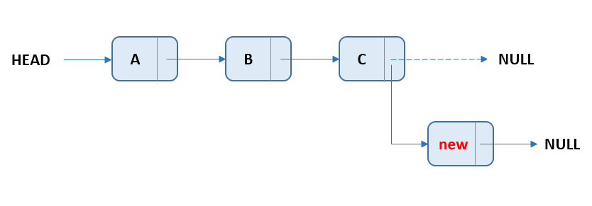

- Hassan – Linked list
He detect nodes.
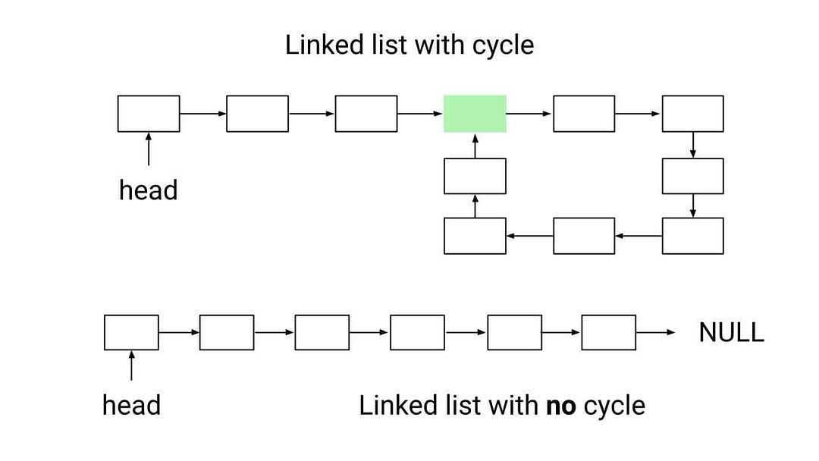

- Maheen – Linked List
Update the list
- Okasha – Linked List (GitHub Manager)
Deleting the Node

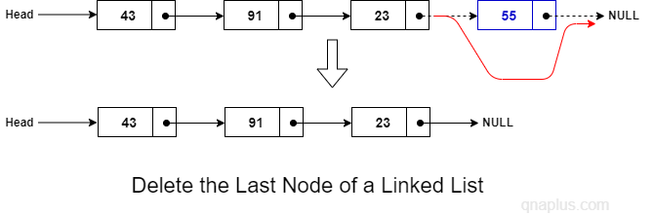

GitHub Page:
https://github.com/MuhammadOkasha/DSA_Project

